Nandikaa Ganesh

Application Development Laboratory – Ex – 1(II)

Name: Nandikaa G

Roll No. 21z325

B.E. CSE III YR

19z612 – ADL Ex. 1 – (ii)

**Problem Statement:**

The Agricultural Equipment Rental App facilitates the efficient and flexible leasing of farming tools. Users can browse a diverse inventory of equipment, explore rental rates, and submit inquiries. The app streamlines the rental process, promoting sustainable farming practices and enhancing accessibility to essential agricultural machinery.

**Index.html:**

<!DOCTYPE *html*>

<html *lang*="en">

<head>

    <meta *charset*="UTF-8">

    <meta *name*="viewport" *content*="width=device-width, initial-scale=1.0">

    <title>Agricultural Equipment Rental</title>

    <style>

        body {

            font-family: 'Inter regular', tahoma, Geneva, Verdana, sans-serif;

            margin: 0;

            padding: 0;

            background-color: #f4f4f4;

            color: #333;

        }

        header {

            background-color: #4CAF50;

            color: white;

            padding: 20px;

            text-align: center;

        }

        nav {

            background-color: #0c6b52d1;

            color: antiquewhite;

            padding: 10px;

            text-align: center;

        }

        nav a {

            color: antiquewhite;

            text-decoration: none;

            margin: 0 15px;

        }

        section {

            margin: 20px;

            padding: 20px;

            background-color: rgb(172, 255, 139);

            border-radius: 8px;

            box-shadow: 0 0 5px rgba(0, 0, 0, 0.5);

        }

        h2 {

            color: #4CAF50;

        }

        ul {

            list-style-type: none;

            padding: 0;

        }

        li {

            margin-bottom: 10px;

        }

        footer {

            text-align: center;

            padding: 10px;

            background-color: #0c6b52d1;

            color: white;

        }

        table {

            width: 100%;

            border-collapse: collapse;

            margin-top: 20px;

        }

        th, td {

            border: 1px solid #ddd;

            padding: 10px;

            text-align: left;

        }

        th {

            background-color: #4CAF50;

            color: white;

        }

        th, td {

        border: 1px solid black;}

        h2{

            color: rgb(24, 80, 3);

        }

      ul{

  list-style-type: circle;

}

      </style>

</head>

<body>

*<!-- Document Tags -->*

    <header>

        <h1>Agricultural Equipment Rental</h1>

        <p *style*="font-weight: bold;">Providing the tools you need for successful farming.</p>

    </header>

<hr>

*<!-- Navigation Bar (Grouping Tags) -->*

    <nav>

        <a *href*="#equipment"><h2>Equipment</a> <br> <hr><br>

        <a *href*="#techniques">Techniques</a> <br><hr><br>

        <a *href*="#contact">Contact</a> <br><hr></h2>

    </nav>

    <hr>

*<!-- Equipment Section -->*

    <section *id*="equipment">

        <h2 *style*="color: rgb(24, 80, 3)">Available Equipment for Rent</h2>

*<!-- Unordered List (Text-level Flow Tags) -->*

        <ul><dd>

            <li>Tractor - Model XYZ</li>

            <li>Harvester - Model ABC</li>

            <li>Plow - Model DEF</li>

        </dd>

*<!-- Add more equipment items as needed -->*

        </ul>

        <hr>

*<!-- Definition List (Text-level Flow Tags) -->*

        <h2>Equipment Details</h2>

        <dl>

            <dt><h3>Tractor</h3></dt>

            <dd>Agricultural vehicle used for various tasks.</dd>

            <dt><h3>Harvester</h3></dt>

            <dd>Machine for harvesting crops.</dd>

            <dt><h3>Plough</h3></dt>

            <dd>Instrument for breaking and turning soil.</dd>

*<!-- Add more equipment details as needed -->*

        </dl>

*<!-- Table (Table Tags) -->*

        <h2>Equipment Rental Rates</h2>

        <table *style*="border: 2px solid black; font: size 50px;">

            <thead>

                <tr>

                    <th>Equipment</th>

                    <th>1 Day</th>

                    <th>1 Week</th>

                    <th>1 Month</th>

                </tr>

            </thead>

            <tbody>

                <tr>

                    <td>Tractor</td>

                    <td>$100</td>

                    <td>$500</td>

                    <td>$2000</td>

                </tr>

                <tr>

                    <td>Harvester</td>

                    <td>$150</td>

                    <td>$800</td>

                    <td>$3000</td>

                </tr>

                <tr>

                    <td>Plow</td>

                    <td>$50</td>

                    <td>$300</td>

                    <td>$1200</td>

                </tr>

*<!-- Add more equipment rows as needed -->*

            </tbody>

        </table>

    </section>

    <br><hr>

*<!-- Techniques Section -->*

    <section *id*="techniques">

        <h2>New Techniques in Agriculture</h2>

        <p>Stay informed about modern agricultural techniques and practices to enhance your yield.</p>

       <h3> <ol>

            <li>Precision Farming</li>

            <li>Vertical Farming</li>

            <li>Drones in Agriculture</li>

*<!-- Add more techniques as needed -->*

        </ol>

    </h3>

    </section>

<hr>

*<!-- Contact Section -->*

*<!-- Contact Section -->*

<section *id*="contact" *style*="margin-top: 20px;">

    <h2>Contact Us for Rental Inquiries</h2>

    <form *action*="/submit_inquiry" *method*="post">

        <label *for*="name" *style*="display: block; margin-bottom: 10px;">Your Name:</label>

        <input *type*="text" *id*="name" *name*="name" *style*="width: 100%; padding: 8px; box-sizing: border-box;" *required*>

<br><br>

        <label *for*="email" *style*="display: block; margin-bottom: 10px;">Your Email:</label>

        <input *type*="email" *id*="email" *name*="email" *style*="width: 100%; padding: 8px; box-sizing: border-box;" *required*>

        <br><br>

        <label *for*="equipment" *style*="display: block; margin-bottom: 10px;">Equipment of Interest:</label>

        <select *id*="equipment" *name*="equipment" *style*="width: 100%; padding: 8px; box-sizing: border-box;">

            <option *value*="tractor">Tractor</option>

            <option *value*="harvester">Harvester</option>

            <option *value*="plow">Plow</option>

        </select>

        <br><br>

        <label *for*="message" *style*="display: block; margin-bottom: 10px;">Additional Message:</label>

        <textarea *id*="message" *name*="message" *rows*="4" *style*="width: 100%; padding: 8px; box-sizing: border-box;" *required*></textarea>

        <br><br>

        <button *type*="submit" *style*="background-color: #4CAF50; color: white; padding: 10px 15px; border: none; border-radius: 4px; cursor: pointer;">Submit Inquiry</button>

    </form>

</section>

*<!-- Footer Section -->*

    <footer>

        <p>Contact us at <a *href*="mailto:info@agrirental.com">info@agrirental.com</a></p>

        <p>&copy; 2023 Agriculture Equipment Rental</p>

    </footer>

</body>

</html>

**Explanation and Output:**

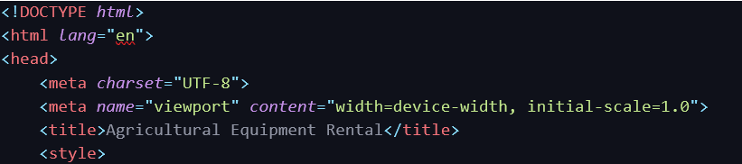

- The `<!DOCTYPE html>` declaration specifies the HTML version being used (HTML5).

- The `<html>` element is the root element of the HTML document, and the `lang="en"` attribute indicates that the document is in English.

- `<meta charset="UTF-8">`: Sets the character set to UTF-8 for proper text encoding.

- `<meta name="viewport" content="width=device-width, initial-scale=1.0">`: Configures the viewport for responsive design.

- `<title>Agricultural Equipment Rental</title>`: Sets the title of the webpage.

- `<style>`: Contains internal CSS styles for the entire document, including styling for the body, header, navigation, sections, tables, and more.

    <header>

        <h1>Agricultural Equipment Rental</h1>

        <p *style*="font-weight: bold;">Providing the tools you need for successful farming.</p>

    </header>

**<header>** - contains the header of the website – usually the name and purpose of the web page

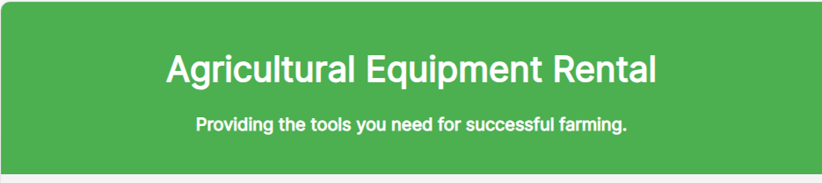

**<hr> -** creates a horizontal line

<hr>

*<!-- Navigation Bar (Grouping Tags) -->*

    <nav>

        <a *href*="#equipment"><h2>Equipment</a> <br> <hr><br>

        <a *href*="#techniques">Techniques</a> <br><hr><br>

        <a *href*="#contact">Contact</a> <br><hr></h2>

    </nav>

    <hr>

* **<nav>**: Navigation bar with links to different sections.
* **<a>**: Anchor tags are used for creating links.
* **<h2>**: Headings used for styling link items.



<section *id*="equipment">

        <h2 *style*="color: rgb(24, 80, 3)">Available Equipment for Rent</h2>

*<!-- Unordered List (Text-level Flow Tags) -->*

        <ul><dd>

            <li>Tractor - Model XYZ</li>

            <li>Harvester - Model ABC</li>

            <li>Plow - Model DEF</li>

        </dd>

*<!-- Add more equipment items as needed -->*

        </ul>

        <hr>

*<!-- Definition List (Text-level Flow Tags) -->*

        <h2>Equipment Details</h2>

        <dl>

            <dt><h3>Tractor</h3></dt>

            <dd>Agricultural vehicle used for various tasks.</dd>

            <dt><h3>Harvester</h3></dt>

            <dd>Machine for harvesting crops.</dd>

            <dt><h3>Plough</h3></dt>

            <dd>Instrument for breaking and turning soil.</dd>

*<!-- Add more equipment details as needed -->*

        </dl>

*<!-- Table (Table Tags) -->*

        <h2>Equipment Rental Rates</h2>

        <table *style*="border: 2px solid black; font: size 50px;">

            <thead>

                <tr>

                    <th>Equipment</th>

                    <th>1 Day</th>

                    <th>1 Week</th>

                    <th>1 Month</th>

                </tr>

            </thead>

            <tbody>

                <tr>

                    <td>Tractor</td>

                    <td>$100</td>

                    <td>$500</td>

                    <td>$2000</td>

                </tr>

                <tr>

                    <td>Harvester</td>

                    <td>$150</td>

                    <td>$800</td>

                    <td>$3000</td>

                </tr>

                <tr>

                    <td>Plow</td>

                    <td>$50</td>

                    <td>$300</td>

                    <td>$1200</td>

                </tr>

*<!-- Add more equipment rows as needed -->*

            </tbody>

        </table>

    </section>

The above section contains – Table, Definition lists, Ordered and unordered lists.

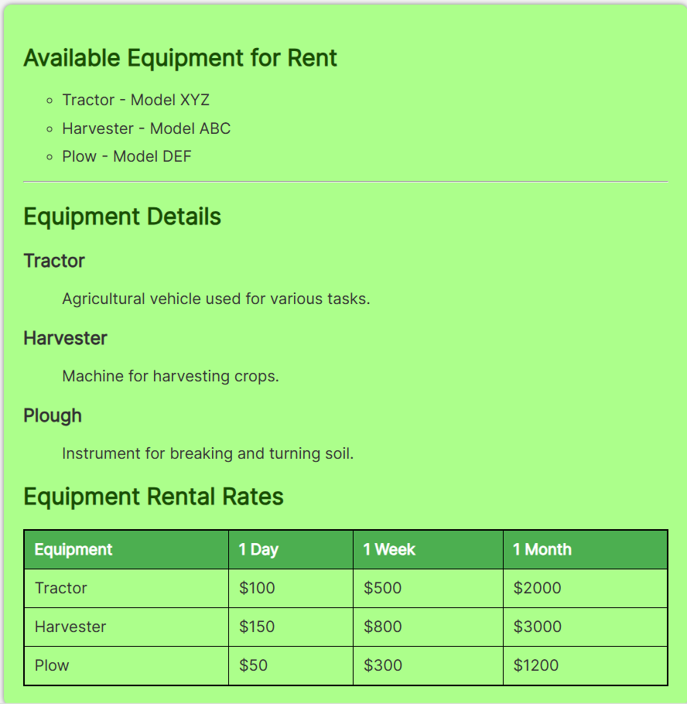

    <footer>

        <p>Contact us at <a *href*="mailto:info@agrirental.com">info@agrirental.com</a></p>

        <p>&copy; 2023 Agriculture Equipment Rental</p>

    </footer>

</body>

</html>

The final section contains the enquiry forms and a submit button designed.

The footer section contains the contact details of the owner of web page and copyrights details.

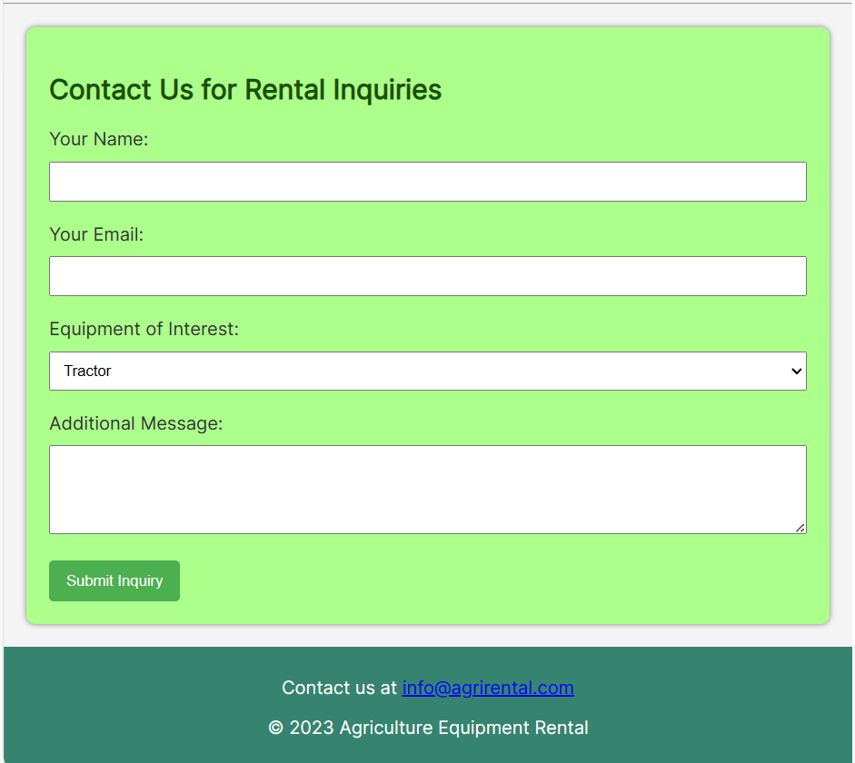

**Output:**

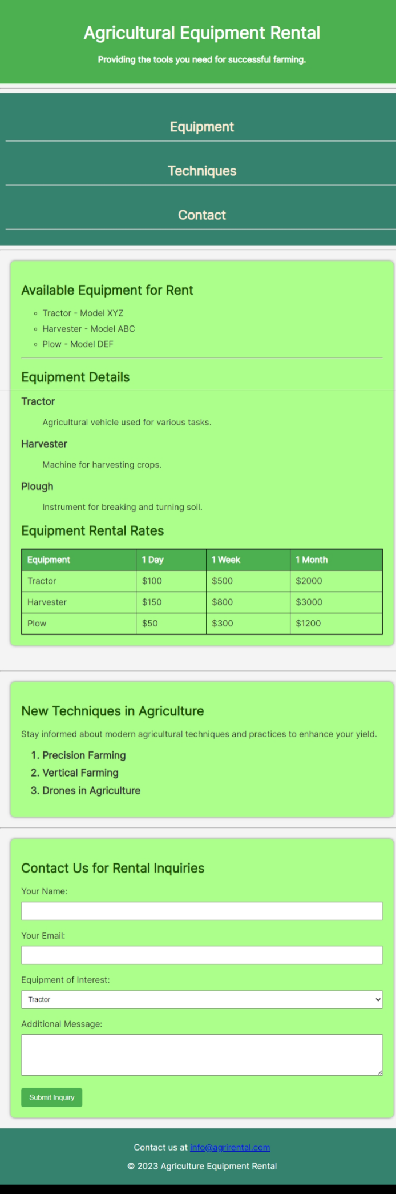

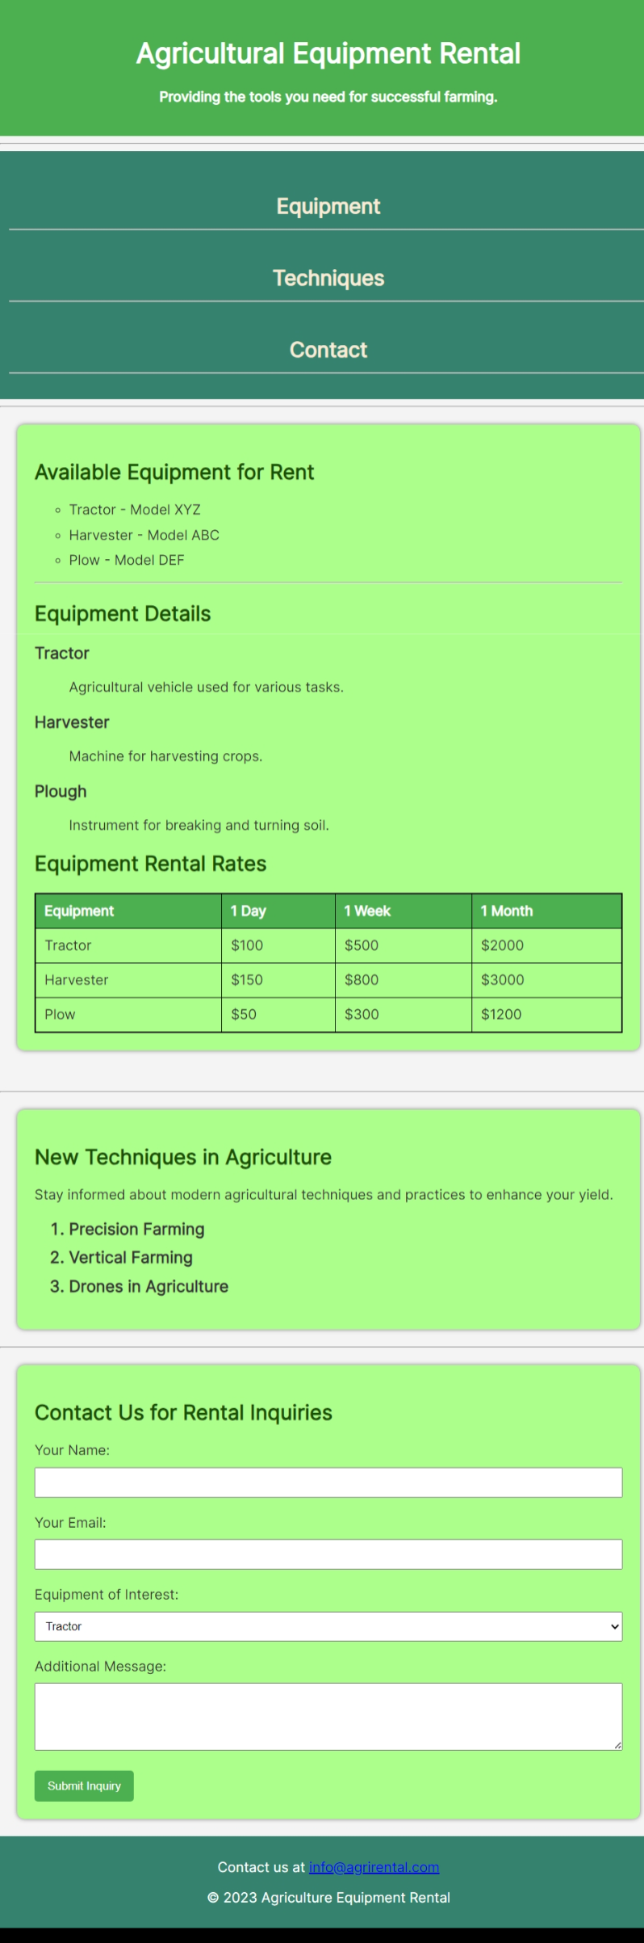

In summary, this HTML code represents a well-structured webpage for an agricultural equipment rental service. It includes sections for displaying available equipment, new agricultural techniques, and a contact form for inquiries. The styling is done using a combination of internal CSS rules to create a visually appealing and responsive layout.